Onboarding Specialist



Your Schedule as a Onboarding Consultant! 📅✨

Great job on completing Day 1 of training—you’re off to a fantastic start! 🎉

Now, it’s time to dive into your customized schedule, tailored to help you develop the skills you need to excel in your role before you hit the field.

How It Works 🚀

- Follow the Schedule: Refer to the time slots and topics outlined for your training.
- Explore Resources: Check out the linked details and resources to enhance your learning.

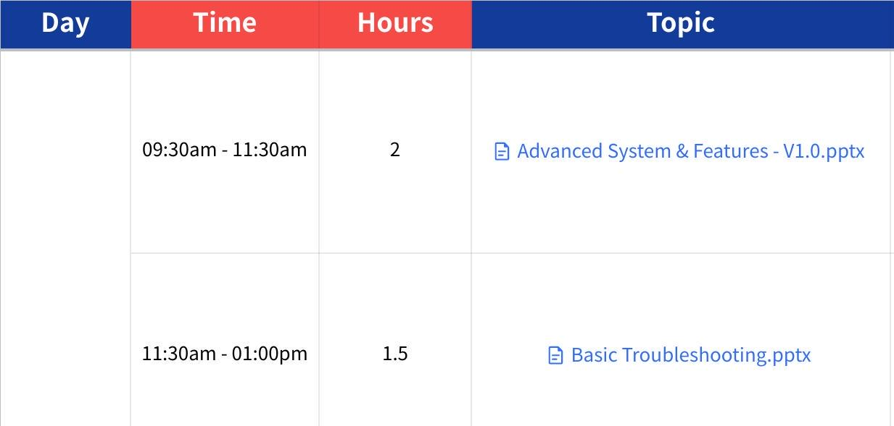
Click the image to view the sheet.

A Few Quick Reminders! 📅

- Stick to the Schedule ⏰
- Follow the timeline like it’s your favorite series finale—no spoilers, complete each task on time!

- Stuck? Reach Out! 🚨
- If you hit any roadblocks or challenges, don’t hesitate to ping your trainer. They're here to help, not judge!

- Finding Your Resources 🗂️
- Simply expand the sidebar under Onboarding Consultant. Everything you need is neatly arranged in line with the agenda above. No scavenger hunts here, we promise!
